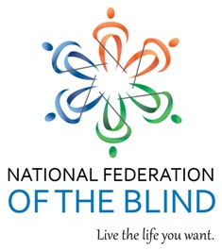
2017 NFB of Kentucky Technology and Business Symposium
September 22, 2017

Hilton Garden Inn Northeast
9:00 A.M. to 4:00 P.M.

Mistress of Ceremonies: Sandra Williams

8:00 AM to 9:00 AM Convention Registration

9:00 AM to 9:10 AM Welcome and Introductions – Todd Stephens, Michael Freholm and Angela Dehart

9:10 AM to 9:30 AM Kentucky Talking Book Library and BARD (Business and
Technology publications on the service), Devon Stivers and Janet Chisman

9:30 AM to 9:55 AM HIMS Technology, Dave Wilkinson

9:55 AM to 10:35 AM APH, Larry Skutchan and Joe Hodge

10:35 AM to 11:00 AM Freedom Scientific, Greg Blackman and Ron Dukes

11:00 AM to 11:30 AM Apple or Android – That is the question, David Brown and Ryan Harvey
11:30 to 11:35 AM A Word on Vendors and Displays

11:35 AM to 1:00 PM Lunch and Visit with Vendors

1:00 PM to 2:00 PM Panel Featuring Successful Employed Blind Role Models: Sandra Williams, Lora Stephens, Jayne Seif, Michael Freholm, and Bill Brooks, introduced by Todd Stephens, moderated by Hellena Emery

2:00 PM to 3:00 PM SCORE Association – free Small Business Advice workshop,
Retired Business Executive, Russ Leathem

3:00 PM to 3:45 PM Office for the Blind on Work Incentive and Planning Assistance (WIPA), Blindness Rehabilitation and Case
Management, Kennetta Freholm and Tonisha Everhart

3:45 PM to 4:00 PM Wrap-up/Adjournment

Sponsorship and Awards

- The 2017 platinum award goes to Retina Associates of Kentucky for sponsoring the 2017 Technology and Business Symposium luncheon.

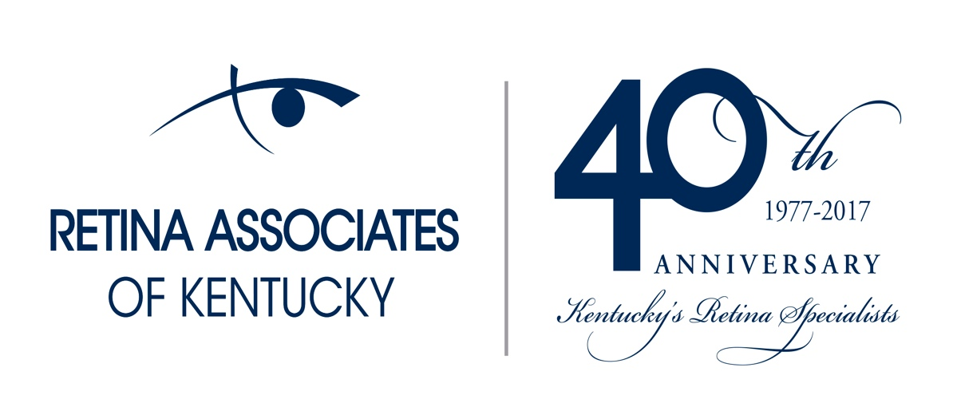

- The 2017 Gold sponsor goes to Vanda Pharmaceuticals for sponsoring the 2017 Technology and Business Symposium conference room.

